**Engine Friction**

Objective:

Understanding the engine friction concept, and studying some empirical formula to calculate engine friction.

What is friction work?

Difference between work delivered to the piston and usable work delivered to the drive shaft.

Friction work (F.B) = Indicated work (I.P) - Brake work (B.P)

Friction components:

1-Pumping work: work consuming in drawing new charge and expel burned gases (Intake +exhaust).

2-Rubbing Friction: work due to overcome the resistance (relative motion) as in piston rings ,skirt, cylinder wall, crank shaft, cam shaft, valves .

3-Accessories work: work consuming in powering accessories as Fan, fuel pump, generator.

The friction work could be measured using several methods as (Drawing Willan’s line , Morse test , Motoring test ,…..etc.)

In this lab we will Measure F.P by Wilson’s line Method:

We will use constant speed for motor (N)= 1000 RPM

Procedure

1. Start the engine, let it to warm up and reach steady state.

2. Load the engine with 5 Lb with respecting the const. N(rpm) and measure fuel mass flow rate.

3. Increase the load to 10Lb and also make sure that the speed is constant and measure the fuel mass flow rate.

4. Repeat for 15Lb and 20Lb and put the results in the table.

ρfuel = 830 Kg/m3 mof = ρfuel*Qf* Qf*=volume/time volume = 50 mlitre BP(KW) = load(lb) * N(rpm) * 0.746 / 2800

Graph:

*At N=1000 rpm:

|  |  |  |  |  |
| --- | --- | --- | --- | --- |
| Load (lb) | 5 | 10 | 15 | 20 |
| Time (sec) | 129 | 119 | 78 | 68 |
| Bp (kW) | 1.33 | 2.66 | 3.996 | 5.329 |
| Qf* | 3.87*10^-7 | 4.2*10^-7 | 6.41*10^-7 | 7.535*10^-7 |
| mf | 3.217*10^-4 | 3.487*10^-4 | 5.32*10^-4 | 6.103*10^-4 |

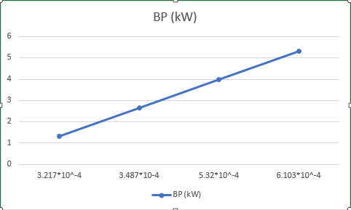

*At N=1200 rpm:

|  |  |  |  |  |
| --- | --- | --- | --- | --- |
| Load (lb) | 5 | 10 | 15 | 20 |
| Time (sec) | 97 | 91 | 62 | 57 |
| Bp (kW) | 1.598 | 3.197 | 4.796 | 6.39 |
| Qf* | 5.154*10^-7 | 5.495*106-7 | 8.06*10^-7 | 8.77*10^-7 |
| mf | 4.278*10^-4 | 4.56*10^-4 | 6.69*10^-4 | 7.2791*10^-4 |

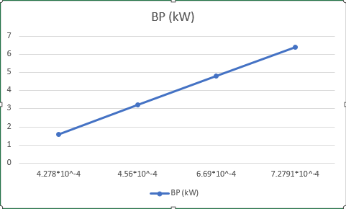

Results:

By intersecting the line with the x-axis:

At friction power at 1000 rpm =6.7(kW)

At friction power at 1200 rpm =8.13(kW)

Comment:

The friction power increases by increasing the speed as the friction power is directly proportional to the square of the speed of the motor.